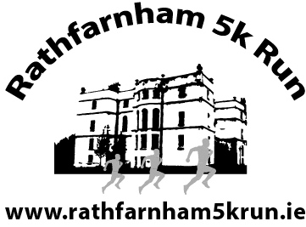 | Registration Form  New Ireland Rathfarnham 5k Run  Sunday 25th September 2016 at 10.00
(Postal entries cost €20 each, Online entries cost €21.40 and €25 on Sunday 25th Sept.)
Present this form at Rathfarnham WSAF AC Clubhouse, Main Street, Rathfarnham on the Friday/Saturday 23/24 Sept. or at Terenure College Gym on Sunday 25th Sept (8.00 – 9.30)
Name (PRINT)_______________________________________________________________
Address____________________________________________________________________
__________________________________________________Date of Birth______________
Mobile___________________________E-Mail_____________________________________
AAI Club if applicable__________________________________________________________
Circle correct categories: | Male Female Junior (U.20) Senior Master  Over 40 Over 45 Over 50 Over 55 Over 60

I agree to accept the rules and conditions of this event and enter at my own risk.
Signature_____________________________
Fill in this form for each person to be entered and send it to Owen McLoughlin, 17 Barton Drive, Rathfarnham, Dublin 14 by Tuesday 20th Sept. with €20 for each entry. Please make cheque out to Rathfarnham WSAF Athletic Club.
Pick up Number, T-Shirt and Goody Bag at Rathfarnham WSAF AC Clubhouse, Main Street, Rathfarnham on the Friday 23rd Sept. (19.00 – 21.00) or Saturday 24th (12.00 – 16.00). You can also pick them up at Registration in Terenure College Gym, Templeogue Road, Terenure on race day 25th Sept (8.00 – 9.30).

